Operational Concept Document: Source Code Repository Architecture

Matthew Synborski | matthewsynborski@gmail.com
CSE-681 Project 5 - Fall 2013 – For Dr. Jim Fawcett
1 Executive Summary 3
2 Introduction 3
3 Top Level Architecture 4
3.1 Client 5
3.2 Repository Server 6
3.3 Structure 6
4 Plugin-based Architecture 7
4.1 Plugin Based Virtual Server 7
4.2 Plugin Based Client 7
4.3 Cloning 9
5 Detailed Architecture: Client 10
5.1 Client: Collaborator 11
6 Detailed Architecture: Repository Server 19
6.1 Repository Server: Comm Package 20
6.2 Repository Server: RepoQueryServer/Client Packages 22
6.3 Repository Server: PackageDeleteServer/Client Packages 28
6.4 Repository Server: NavGetServer/Client Packages 32
6.5 Repository Server: PackageGetServer/Client Packages 35
6.6 Repository Server: PackageCheckinServer/Client Packages 39
6.7 Repository Server: MetadataUpdateServer/Client Packages 43
6.8 MetadataRecursiveCrawl 46

Executive Summary
Large software, research and development, media and news companies all employ large groups of people working on large numbers of files. A set of tools that can provide simple views of these work packages and relationships thereof, would allow these organizations to get their work done more efficiently. Software, test, high-level staffing and financial files can be stored in a remotely accessible set of virtual servers.
Each server can be customized to perform certain capabilities specific to a given functional area. Each server can also be managed by a different group of users and all of the servers can communicate with each other. For example, the Repository Server can be used to manage source code packages. A test server can automatically retrieve a set of source code packages, compile and run them, along with a set of unit tests. The results from the unit tests can be stored internally to the test server, while a summary of the latest test results can be appended to the metadata for the source code package in the Repository Server. If repeated failures occur on a nightly basis, a notification or set of statistics can be sent to the project server so project management can address repeat problem areas.
The Repository Client and Repository Server are a two source code content repository software tools that provide a subset of these capabilities. The Repository Client and Repository Server provide functionality that satisfy the project 5 requirements, and are designed for maximum reuse of code modules between the two software instances, as well as with previously developed text analysis and metadata generation tools.
The software architecture (detailed further in §3) of the Repository Server and Client employ AppDomains and pairs of plugin files that compose each major “chunk” of functionality. The plugin “packages” share much of the same low level functionality, and differ from each other only to carry out client and server-specific functions.

Introduction
What are Repository Client and Repository Server?
Repository Client and Server are two pieces of software that allow remote storage files and associated properties (referred to, from now on as “metadata”). They provide the ability to view the files and to edit the properties. Additionally, Repository Client and Server provide a view of relationships between files. These relationships are specified by the user when the files are inserted, or when a package owner chooses to use a newer version of a parent package. Relationships are presented to the user in terms of parents and children of a given file. The Repository Client and Server support queries of text content in the files themselves, as well as queries of the files’ metadata. Queries can be text-only, metadata-only, both text and metadata together, and can include regular expressions.

Top Level Architecture
The Repository Server and Client are portions of the Software Development Collaboration System shown below in the architecture diagram in Figure 1. This Operational Concept Diagram will cover the Client and Repository Server. It will not cover the Project Server or Test Harness Server, but will take their design concepts into account in order to provide a full discussion and coverage of the Client and Repository Server.
Figure 1: Software Development Collaboration System Context Diagram

Client
The client is the view and control of the entire federation of servers in the collaborative software development system. At the highest level, its uses are partitioned into two sections, shown below in Figure 2. The first section is server view and control. The second is cross-client collaboration.
Figure 2: Client Usage Partitions
Regarding the first section, the client offers the ability to control and perform oversight of the development project, check in, check out, analyze and view reports on source code packages, and specify post-test configurations, run tests and view test reports.
Regarding the second section, the client offers the ability to exchange documents, chat with other users via the client interface, and perform whiteboard collaboration.

Repository Server
The Repository Server is the container for all work packages within the Source Code Repository, shown below in Figure 3. It contains all of the stored data that is requested by the Project Server. Via a client interface, it provides facilities for checking files in, checking out, generating reports, and performing and reporting analyses. The Repository Server also provides code to the Test Harness Server, and accepts and stores the test results.
The Repository Server is one of many servers that are composed from a general server architecture. This architecture is further described below in the Virtual Server section.
Figure 3: Repository Server Usage Partitions

Structure
The Repository Server is composed of the Server side set of plugins (.dll files), which are loaded at runtime. Each server-side plugin contains communications and tactical implementation for separate functions of the Repository Server. The plugin based architecture allows new features to be added to the Repository Server without affecting the overall architecture. It also allows new server types to be developed with minimal rework at the design-level.
On the Client side, the graphical user interface is composed of client-side plugins corresponding to the functions of the Repository Server. For each major feature/function of the Repository Server/Client, a pair of .dll files exists. Each pair of these .dll files is referred to as a plugin.

Plugin-based Architecture

Plugin Based Virtual Server
Because the needs of a development team are constantly changing as a program, project, or company evolve over time, it is desirable to provide a changing toolset. The assets associated with program management, software development, and verification and validation are different in terms of content. They are not different in terms of the general actions needed between the storage facility and the user. In all cases, the facility must:
- Assert access control policy: Control who can log in and what they can read and write
- Allow users to insert content as appropriate (store)
- Allow users to get information about content (query)
- Allow users to change the state of content (command)
The Repository Server is one of a myriad possible server partitions that can conform, architecturally to the above. In terms of its specific requirements
- Access control: The Repository server will assert access control. It will only allow users associated with permitted groups (developers, managers, testers) to read software content. It will only allow users associated with the testers group to write test results. It will only allow the user listed as the responsible individual to check in a file.
- Store: The Repository Server will allow software assets to be stored on its file system. For each software content asset (code file, documentation file, analysis file), a metadata file will be generated and stored alongside the content asset.
- Query: The Repository Server will support queries on the data (software assets and associated metadata).
- Command: The Repository Server will support a file deletion command, available only to users associated with the admin group.
The IServer generalized server architecture features a plug-in based design. Each Server that implements this architecture contains any number of IStoreServer, ICommandServer or IQueryServer plug-ins.

Plugin Based Client
The IClient generalized client architecture features a plug-in based design, similar to the IServer architecture. The Client contains a number of IStoreClient, ICommandClient or IQueryClient plugins. The client provides a WPF-based graphical user interface via each client-side plug-in. The client plugins display the views to the user, and for each plug in, perform the appropriate message forming, and passes resulting (XML) messages to the corresponding server plugins on the appropriate server via the Comm package. Message routing is handled by the client, as each client plug-in implements its own WCF-based communicator via the Comm package.
The generalized architecture of a virtual server is shown below in Figure 4.

Figure 4: Generalized Server Architecture UML Package Diagram

Cloning
The federated “virtual” servers are capable of “cloning”. That is, for test, simulation and development purposes, a full set of packages can be retrieved from a remote Repository Server. The local Repository Client and remote Repository Server both operate upon a set of “plugin” files, client and server .dll files that share several facilities documented within this Operational Concept Document. The same files used by the Repository Server are found on all computers running the Repository Client. When the user selects the “Clone” feature on the Repository Client, the following activity diagram shown below in Figure 5 is performed. For more information on the PackageGet plugin package, see §6.5.
Figure 5: Cloning (PackageGet) UML Activity Diagram

Detailed Architecture: Client
The Repository Client is a subset of the plug-in based Client’s full functionality. The plug-in based client will consist of plug-ins for the Test Client, Project Client and Repository Client.
The following section is concerned with only the portions of the client that pertain to the Repository Client and Server functionality.
The specific architecture for the Repository Client is shown below in Figure 5.
Figure 6: Respository Server UML Package Diagram

Client: Collaborator

Concept
The collaborator package provides all client to client collaborative functionality. The collaborator is a WPF-based pane within the Client graphical user interface (GUI) that contains separate sections for collaborative work. The collaborator is entirely separate from the communications (WCF-based message passing) used within the client-server plug-ins. Clients join a multicast-based “conversation” and have access to all content posted by any other user. Conversations will be divided by port number, so that multiple conversations and group members can be kept separate. Further, secure conversations can be encrypted, with their encryption keys stored within the repository server using its existing user access policy.

Uses
- Whiteboard collaboration – The collaborator presents a combined view of a 2-dimensional drawing. Each user posts graphical features, and the resulting drawing is rendered by each Client’s collaborator.
- Chat - A standard chat interface is provided. Upon entering a “conversation”, the user’s username is displayed in a list of participants. Messages are displayed at the bottom of the pane as the user types. When a user sends a message, the message is time stamped and displayed at the bottom of the message transcript history.
- Document share – The collaborator provides an informal file share. Files are available to all participants in a given conversation until the last user exits from the conversation. Additionally, an interface is provided for taking informal files (those files produced during a conversation) and checking them in to any of the servers.
The collaborator view is shown in a mockup diagram, below in Figure 6.
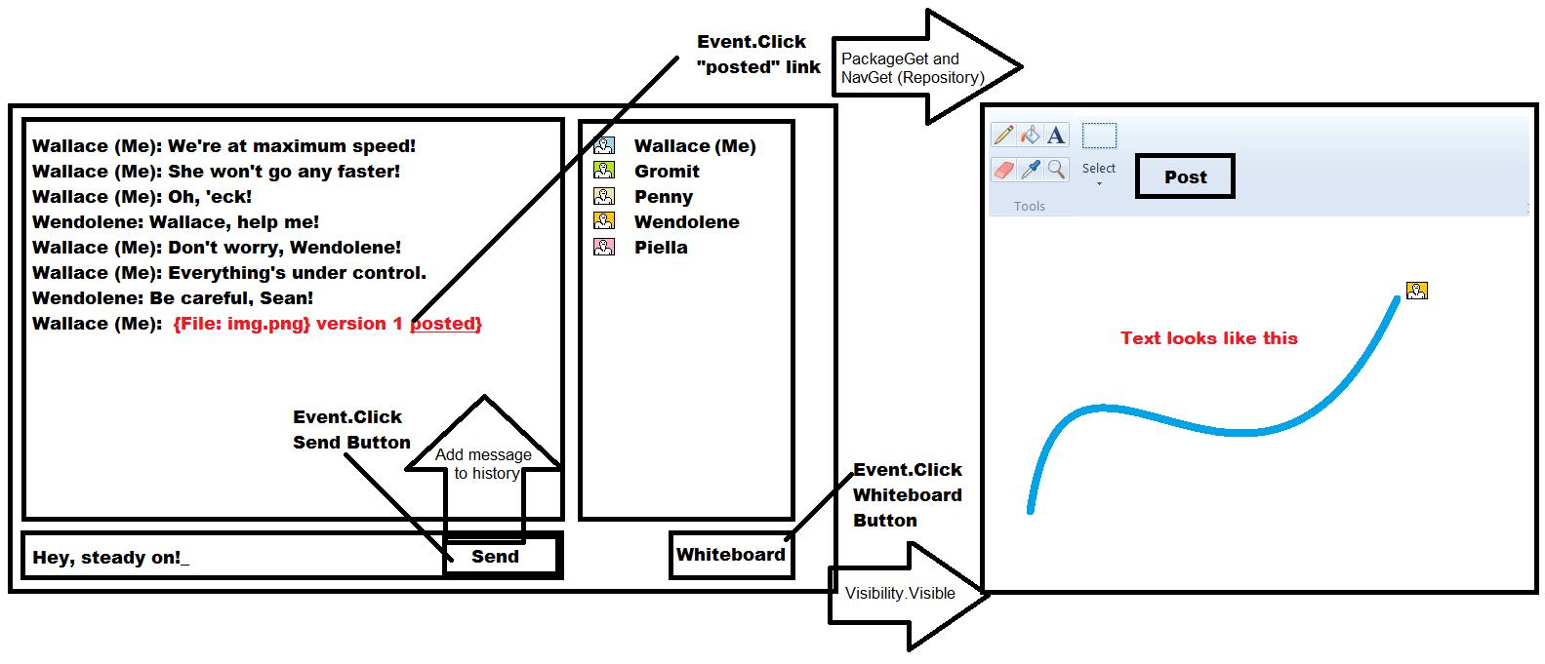
Figure 7: Collaborator Mockup Diagram

Structure
The Collaborator package diagram is shown below in Figure 7. The Collaborator follows a model-view-control pattern. The Chat and Whiteboard functions are implemented via the CollaboratorChat and CollaboratorWhiteboard packages, which use the McastComm communications class.

Figure 8: Collaborator UML Package Diagram

Critical Issues
Security – The MCastComm class uses UDP multicast as an underlying communications infrastructure. Anyone connected to the network hardware can perform a multicast join and listen to the content in the conversation. To secure the content, an optional encryption can be used in the conversation. If encryption is enabled, each users’ client will retrieve an encryption key from the repository server. The multicast messages are then encrypted by the MCastComm package, to prevent unwanted recipients from being able to use the multicasted content.
Flexibility – The Collaborator package must support users coming and going over the course of the conversation. Rather than juggling a list of participants in the conversation, and unicasting content to each user, multicast allows for each user joining in the multicast group. Any time a user wants to post content, the user’s client only needs to post once, via the MCastComm MulticastSender object.
Ease-of-use – The client user will retrieve a single file from the repository server containing a list of conversations. The conversation list contains a multicast address and port number. The multicast address, in default cases, doesn’t need to change. Multiple conversations are allocated via port number. When a conversation is started, the client updates the conversation list so that it contains the conversation address and port number. When the conversation is terminated or timed out, the conversation list is updated to remove the conversation.

Prototype: MCastComm Demo
An example implementation for the multicast communication package, MCastComm was created, to demonstrate the feasibility of using UDP multicast for a collaborative communications backend. The requirements for such a communicator were to support asynchronous joins, and to insulate the Client from having to keep a table of remote users. UDP multicast, though subject to security vulnerabilities, is a good starting point, as evidenced by the prototype.
using System.Net.Sockets;
using System.Net;
using System.Threading;
using System;

namespace multiCastComm
{
public class someEventArgs : EventArgs
{
private string _msg;

public someEventArgs(string msg)
{
_msg = msg;
}

public string msg
{
get
{
return _msg;
}
set
{
_msg = value;
}
}
}

public class McastComm
{
private send s = null;
private recv r = null;

public McastComm(recv _r)
{
Console.WriteLine("Firing up a communicator ");
r = _r;
r.incomingPacketEvent +=
new recv.incomingPacketEventHandler(DisplayContents);

new Thread(r.start).Start();

}

public void broadcastPacket(String packetContent, String port)
{
s = new send("224.5.6.7", port, "10", packetContent);
}

public void DisplayContents(object obj, EventArgs seva)
{
String filename = ((someEventArgs)seva).msg;
Console.WriteLine("{" + filename + "}");
Console.WriteLine();
}
}

public class send
{
public send(string mcastGroup, string port, string ttl, string packetContent)
{
IPAddress ip;
try
{
Console.WriteLine("MCAST Send on Group: {0} Port: {1} TTL: {2}",mcastGroup,port,ttl);
ip=IPAddress.Parse(mcastGroup);

Socket s=new Socket(AddressFamily.InterNetwork,
SocketType.Dgram, ProtocolType.Udp);

s.SetSocketOption(SocketOptionLevel.IP,
SocketOptionName.AddMembership, new MulticastOption(ip));

s.SetSocketOption(SocketOptionLevel.IP,
SocketOptionName.MulticastTimeToLive, int.Parse(ttl));

byte[] b = Encoding.ASCII.GetBytes(packetContent);

IPEndPoint ipep=new IPEndPoint(IPAddress.Parse(mcastGroup),int.Parse(port));

Console.WriteLine("Connecting...");

s.Connect(ipep);

s.Send(b,b.Length,SocketFlags.None);

Console.WriteLine("Closing Connection...");
s.Close();
}
catch(System.Exception e) { Console.Error.WriteLine(e.Message); }
}

public class recv
{
Socket s = null;
public delegate void incomingPacketEventHandler(object sender, EventArgs seva);
public event incomingPacketEventHandler incomingPacketEvent;

private int port;

public recv(string mcastGroup, string port)
{
this.port = int.Parse(port);
s=new Socket(AddressFamily.InterNetwork, SocketType.Dgram, ProtocolType.Udp);

IPEndPoint ipep = new IPEndPoint(IPAddress.Any, this.port);
IPAddress ip = IPAddress.Parse(mcastGroup);
s.SetSocketOption(SocketOptionLevel.IP, SocketOptionName.AddMembership, new MulticastOption(ip, IPAddress.Any));
// Allows multiple sockets listening on a single port, on a given machine
s.SetSocketOption(SocketOptionLevel.Socket, SocketOptionName.ReuseAddress, true);
s.Bind(ipep);
Console.WriteLine("Starting multicast receiver on port {0}", this.port.ToString());
}

public void start()
{

while (true)
{
String message;
byte[] b = new byte[10];
Console.WriteLine("Waiting for data..");
s.Receive(b);
string str = System.Text.Encoding.ASCII.GetString(b, 0, b.Length);
Console.WriteLine("RX: " + str.Trim());
message = str.Trim();
someEventArgs seva
= new someEventArgs(message);
if (incomingPacketEvent != null)
incomingPacketEvent(this, seva);
}
}

public static void Main(string[] args)
{
new recv("224.5.6.7","5000");
}
}
}

The demonstration should verify the ability for two clients, A and B to communicate. One client (A) should post a series of messages, which should show up on both clients’ (A and B) “screens”. Then, after the “conversation” stops, an additional client (C) should arrive and post a series of messages, which are displayed on all three “screens”.
Below is a transcript from the demonstrated “conversation”. User A multicasts a series of 10 messages to all clients. Later, user C arrives within the conversation, and broadcasts to all clients.
Enter the name of the user  A  Starting multicast receiver on port 5000  Firing up a communicator  Waiting for data..  MCAST Send on Group: 224.5.6.7 Port: 5000 TTL: 10  Connecting...  Closing Connection...  RX: A: 0  {A: 0 }  Waiting for data..  MCAST Send on Group: 224.5.6.7 Port: 5000 TTL: 10  Connecting...  RX: A: 1  {A: 1 }  {truncated}  Waiting for data..  Closing Connection...  MCAST Send on Group: 224.5.6.7 Port: 5000 TTL: 10  Connecting...  RX: A: 9  Closing Connection...  {A: 9 }  Waiting for data..  Done  RX: C: 0  {C: 0 }  Waiting for data..  RX: C: 1  {C: 1 }  {truncated}  Waiting for data..  RX: C: 9  {C: 9 }  Waiting for data.. | Enter the name of the user  C  Starting multicast receiver on port 5000  Firing up a communicator  Waiting for data..  MCAST Send on Group: 224.5.6.7 Port: 5000 TTL: 10  Connecting...  Closing Connection...  RX: C: 0  MCAST Send on Group: 224.5.6.7 Port: 5000 TTL: 10  Connecting...  {C: 0 }  Waiting for data..  RX: C: 1  {C: 1 }  Closing Connection...  MCAST Send on Group: 224.5.6.7 Port: 5000 TTL: 10  Connecting...  Closing Connection...  Waiting for data..  RX: C: 2  {C: 2 }  {truncated}  Waiting for data..  Closing Connection...  RX: C: 9  {C: 9 }  Waiting for data..  Done

Five Pillars of Security – Multicast Communication Prototype
While the prototype does demonstrate the ease of handling communications to an ever changing set of multicast participants, it is absolutely necessary to include security protections. According to ISO, a secure system must provide confidentiality, integrity, authentication, access control, and non-repudiation.
- Confidentiality: No untrusted party can access appropriate messages.
- Integrity: Messages cannot be changed during transit without being discovered.
- Authentication: The message needs to be sent by the person/machine who claims to have sent it.
- Access control: Only those users enabled can access the data.
- Non-repudiation: The receiver can prove that the sender actually sent the message.

Requiring any user to retrieve an encryption key from the Repository server satisfies the requirement for authentication and access control. Confidentiality is satisfied with the assumption that the method of encryption is satisfactory for keeping the conversation confidential.
Integrity is not satisfied in this example. In a more satisfactory example, a checksum should be calculated such that tampering with the message would be detected by the receiving client. Additionally, it could be desireable to compute a rolling checksum with each message in the conversation, and broadcast the checksum as part of each subsequent message. Either method is acceptable for assurance of security integrity.
Non repudiation is not truly satisfied in this example. The sender name is provided along with each message. It could be spoofed, however, since the identification is a short human-readable string. To enhance non-repudiation, it would be desirable to encode the MAC address or originating IP address of the sender. A spoofed message from an alternate sender would be detected as it would contain a differing MAC or IP address.

Detailed Architecture: Repository Server
The Repository Server contains a number of server-side plug-in packages, shown below in the package diagram in Figure 8. The top level packages are common to the test and project server architecture, allowing for flexibility and full customization of what features a server will be equipped with. The Comm package provides a common transport method for all outgoing and incoming traffic passed to the server packages.
The Server packages below the top level provide the Repository Server functionality.
Figure 9: Repository Server UML Package Diagram

Repository Server: Comm Package

Concept
The communications package within this architecture supports unicast communications between a given client instance and a given server instance. For messages to get from one client to one server instance, or vice versa, a pair of communicators performs one-way communication. Communications cease when a sender, belonging to the client or server issues a terminating message.
The information needed to route a response message is provided as part of the incoming message. The receiving communicator can provide a response back to the source of the original message.

Uses
The Repository Server uses the communication package for the following transactions:
- Storing a new source code package to the server
- Storing metadata for a source code package
- Revising (commanding) metadata for a source code package
- Querying for information in the source code packages on the repository files
- Querying the encryption key for a secure collaboration conversation.
- Starting (commanding) a new collaboration conversation
- Terminating (commanding) a collaboration conversation
- Commanding a deletion of a source code package

Structure
The UML package diagram for a Client or Server class composing the communicator (this example refers to “specialized communicator”) is shown below in Figure 10.
Figure 10: Communicator UML Package Diagram

Critical Issues
Expandability – Because the federated server concept requires multiple servers talking to each other, and to multiple clients, the need for concurrent communications with multiplicity is very critical. Communicators must be able to coexist with potentially thousands of other communicators running concurrently on the same machine, as well as on the same network.
Resource usage – Because of the need for expandability, it is important to ensure that communications, once complete, return all resources. Additionally, because of the multiplicity of communications, individual instances of the communicator should be lightweight.

Repository Server: RepoQueryServer/Client Packages

Concept
The RepoQueryServer and RepoQueryClient make it possible for the user to retrieve information from the body of source code packages stored within the Repository Server. The RepoQueryServer receives the query, performs the query, packages the query results into an XML message and sends the response to the RepoQueryClient. The RepoQueryClient allows the user to specify the query terms. When the query response arrives, the RepoQueryClient unpacks the response and displays the results of the query.

Uses

Users
The user will be the sole user of the RepoQueryClient. The RepoQueryServer will be responsible for handling queries from the user, via the RepoQueryClient, and for handling queries from the test and project servers when they request information pertaining to source code packages.

Uses - RepoQueryClient
The user can specify one or more category filter terms. If a category is specified, only files with associated metadata containing one or more of the categories will be queried using the following usage steps.
The user can specify metadata query terms. For each Metadata Query Term, each metadata file in the aforementioned category or categories will be searched for metadata tags containing the Query Term or Terms. If any are found, the filename, version and tag/value for each Query Term is returned.
The user can specify text strings, or regular expressions to find within content files within the Repository Server. If the aforementioned category or categories are specified, only files with the associated category information will be searched, to server workload associated with this query. Any filename containing the text string or regular expression will be returned, along with its full metadata content.
The View of the RepoQueryClient is shown below in the prototype diagram in Figure 10.
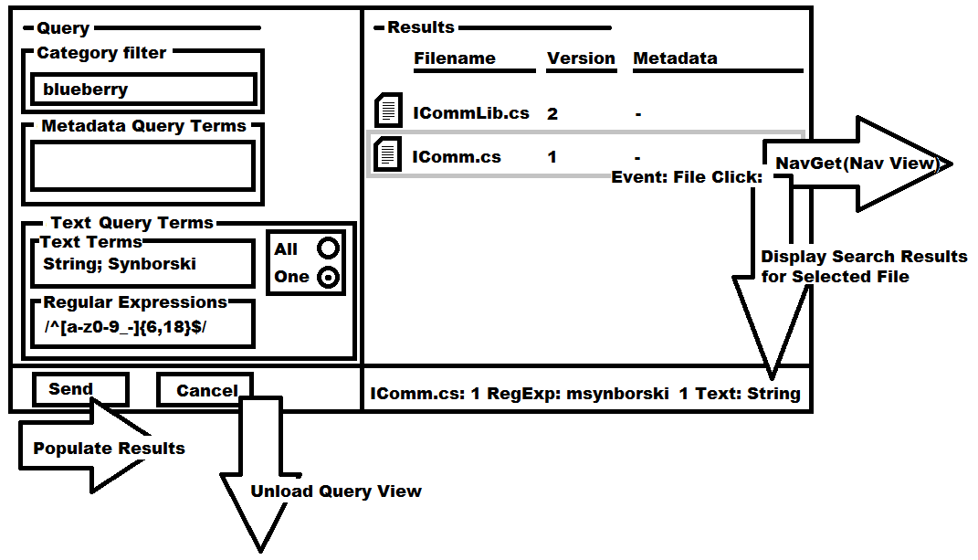
Figure 11: RepoQueryClient View Prototype Diagram

Uses – RepoQueryServer
The RepoQueryServer handles incoming RepoQueries from the RepoQueryClient as well as from the Test and Project Servers.

Structure
When the user enters this view from the Nav View, the empty Query view appears with no files in the right side (“Results”) pane. The user enters Category, Metadata Query Terms, Text Terms and/or Regular Expressions. If the user presses the Send button, the terms are packaged up into a RepoQuery Service Message and sent via the Communicator package to the RepoQueryServer. The RepoQuery Service Message is handled by the RepoQueryServer, which performs the RepoQuery upon its repository content files.
The RepoQuery package diagram is shown below in Figure 11.
Figure 12: RepoQuery Plugin Package Diagram
RepoQueryClientView.xaml – Contains the WPF-based XAML and code-behind that implements the Query View shown in Figure 10. The implemented class is a Window object.
RepoQueryClient – This package contains the implementation for an AbstractCommunicator, which is used in conjunction with messaging defined in RepoQueryService. RepoQueryService is a shared library used by RepoQueryServer, which provides the construction of the RepoQuery payload in the form of well-formed XML. The communications provided by the RepoQueryClient communicator creates a Sender when the user presses the Send button on the Query View. The Client creates a Receiver for the response, which times out after 5 seconds if a query response has not been received. If a query response is received containing a heartbeat response payload, the 5 seconds is extended.
RepoQueryServer – This package contains the implementation for an AbstractCommunicator, which is uses the RepoQueryService in a similar manner as the client. The Server provides a persistent receiver that waits for incoming queries in the form of a RepoQuery, which is implemented in the RepoQueryService package.
RepoQueryService – This package contains static member functions for populating an XML formatted query given a series of inputs:
- Categories
- Text Search Terms
- Text Search Configuration Terms (find all vs. find one)
- Text Search Regular Expressions
- Metadata Search Terms
The RepoQueryService package also contains static member functions for unpacking data from a RepoQuery response. Namely files, their versions, their associated metadata, their regular expressions contained in the aforementioned file, and their Text Search Terms contained in the aforementioned file.
TextQuery – This package contains a generalized Text and Metadata search facility. The aim in generalizing this package is to provide the ability to search a given file system for content and associated metadata to support a diverse field of applications containing and reaching beyond the Repository, Test and Project Servers. For a given file, the TextQuery will provide the following facilities in numerical order of execution:
- Look for an associated metadata file. If one is not located, cease processing and return an indication that the Query did not find a metadata file for the file.
- Look for one or more categories in the metadata file content. If a <categories> tag is found within the file, the provided category or categories in the TextQuery must be found. If one is not located, cease processing and return an indication that the category was not found.
- Look for metadata tags specified by the TextQuery. If any of the tags are present in the metadata file, return the contents. If none are found, return an indication that no metadata content was found. This is not the same as step 1, above.
- Look for text terms specified by the TextQuery. Additional configurations for this facility are also specified in the TextQuery, such as the requirement to find all text strings or one. Return the number of appearances of each text string, along with the position in the file of each occurrence.
- Look for regular expressions specified by the TextQuery. Return the strings found by the regular expression, along with the position in the file of each occurrence.
MetadataLib – This package contains low level functionality that is used by TextQuery, for returning information from Metadata files. The metadata file format is well-formed, flat XML and contains element-only tags for the following:
- Metadata – Root node.
- Type – Can be one of many types of metadata: SourceCode, Authentication, Test, Project, Statistics and so on. When new types of metadata are created, the MetadataLib package must be recompiled and distributed. RepoQuery Metadata is of the type – SourceCode.
- ResponsibleIndividual – Who is the owner user associated with the Package filename. Can be only one Package RI.
- Version – Which version is the metadata. This is written by the Repository Server by the PackageCheckinServer.
- Categories – What categories does the source code package belong to?
- Dependency – Filenames and versions that the given source code package depends on directly.
- Description – Text description of the source code package, written by the Responsible Individual at time of check-in.
- Filename – The filename of the source code package.
- AuthenticationGroup – The user groups that should be able to read and write from/to the package.

Critical Issues
Access Control – The Repository Client and Server provide the facility to access source code files and content that may not be appropriate for every user. Limiting access to files using authentication, user groups and the metadata content will allow only the users that are logged in to the server and have membership in a particular user group to successfully perform a RepoQuery and qualify for a response from the RepoQueryServer.
Search Latency – As the Repository Server fills up with content files, potentially being very large text or source code packages, potentially running text and searches with multiple terms, the processing times for queries can get very high.
According to current human factors practices in server-client systems, the user should never have to wait very long for a visual response, even if processing is incomplete. It is desirable to present the user with a liveliness indicator while text queries are being performed. A 16-petal liveliness indicator will rotate 22.5 degrees clockwise every 500 milliseconds while the search is executing. An example liveliness indicator is shown below in Figure 12.
If the RepoQueryClient does not receive a response for 5 seconds, the liveliness indicator will stop spinning. If the RepoQueryClient does not receive a response for another 5 seconds thereafter, the receiver will fail, and an error window will appear indicating that the Server has unresponsive.

Figure 13: RepoQueryClient Liveliness Indicator

Repository Server: PackageDeleteServer/Client Packages

Concept
The PackageDeleteServer Package allows for the User, if he/she is an authenticated user, belonging to the administrator group, to delete source code packages and metadata files from the Repository Server. The PackageDeleteServer provides the file system functionality, as well as the server-side messaging to remove packages. The PackageDeleteClient provides the view and client-side messaging to do the same.
Source code packages reside on the Repository Server file system. No file is ever permanently deleted from the file system at runtime. The file is removed to a holding folder outside the repository, should the file need to be recovered at a later date. This is possible outside the functionality of the Repository Server, and deletions should be done with discretion by the administrator.

Uses

Users
The user will be the sole user of the PackageDelete package. The PackageDelete functionality will not have implemented accessibility within the Test Server or Project Server.

Uses – PackageDeleteClient
The user can select a file on the Nav View. If the user is authenticated and belongs to the administrator group, a Delete button appears. If the user presses the delete button, and the user is sure they want to delete the file (via a confirmation dialogue), all parent/child relationships are updated within the metadata to remove links. The file and its metadata is moved to the deleted folder.
An example of the PackageDeleteClient’s effect on the Nav View of the Repository Client is shown below in the prototype diagram in Figure 13.
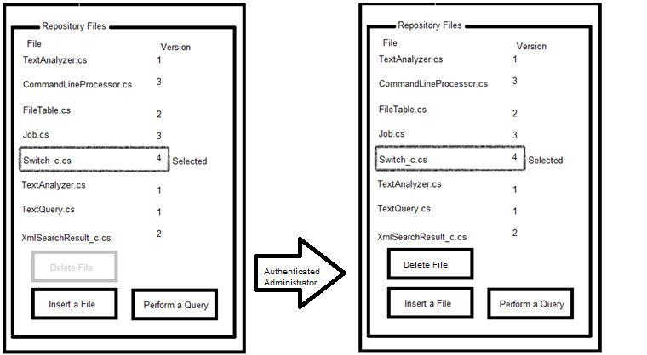
Figure 14: PackageDeleteClient in Nav View

Uses – PackageDeleteServer
The PackageDeleteServer handles incoming PackageDelete commands from the PackageDeleteClient .

Activities: PackageDelete
When a PackageDelete Command message arrives at the PackageDeleteServer, the authentication of the current logged in user is checked against the list of users in the administrator group. If the user is not an administrator, the response to the PackageDeleteClient indicates a failure.
If the current user is authenticated as an administrator, the parent and child dependencies of the given file are “unhooked”, meaning they are updated to indicate a missing dependency. The list of responsible individuals involved in an “unhook” is aggregated, and included in the PackageDelete response for display to the administrator user. The file is then moved to the delete folder.

Structure
The structure of the PackageDelete package is shown below in the UML package diagram in Figure 14. The top level packages, PackageDeleteClient and PackageDeleteServer compose the pair of PackageDelete plugin files.
Figure 15: PackageDelete UML Package Diagram

PackageDeleteClient – The PackageDeleteClient package is a member of the Nav View. The XAML of the Nav View will need to instantiate the control PackageDeleteButton defined in the PackageDeleteClient package. Additionally, the PackageDelete response will be handled using the client-side receiver associated with PackageDeleteClient, and will show/hide the response presentation popup based on the success/failure of the PackageDelete command, and the user inputs.

Critical Issues
Race conditions, access problems – Files that are in use while the administrator user commands a deletion must be gracefully removed. Otherwise, for example, one client will see a result come back for a file that was deleted between the time the file came up in a RepoQuery and the time the file was unlinked and moved to the deleted folder by a separate admin-authenticated user.
In the event that a file is in use, and the file deletion attempt occurs, the file will be removed, but a warning will be issued to the administrator containing a list of potentially affected responsible individuals. The list will be assembled using the parent/child relationships of the affected file and the RIs in the associated metadata thereof. Given the potential inconvenience of a missing file, file deletions must be used with great care.

Repository Server: NavGetServer/Client Packages

Concept
The NavGetServer and NavGetClient packages provide one of the two portions of the navigation view (Nav View) of the Repository Server. This portion of the Nav View is implemented within the NavGetClient plugin. The user is presented with this view upon successful authentication within the Repository Server. The NavGetServer and NavGetClient present the user with server/client communications information (whether the client is connected to the server). Repository contents that are accessible to the authenticated user, given their level of permissions, are displayed to the user. Contents can be filtered by category. File contents and associated metadata are shown for the Current File. Metadata can be modified, depending on the level of authentication of the current user. Any changes to metadata are communicated to any additional users viewing a given file.

Uses

Users
The user will be the sole user of the NavGetClient. The NavGetServer will be responsible for handling queries from the user, via the NavGetClient, and for handling navigation queries from the test and project servers when they request information pertaining to Repository Content information.

Uses - NavGetClient
Upon initial connection, the NavGetClient performs a NavGet Query to the NavGetServer. The results of the NavGetQuery are displayed within the leftmost pane, entitled “Navigation”, under the Categories and Files listbox. The full Nav View is shown below in the prototype diagram in Figure 15.
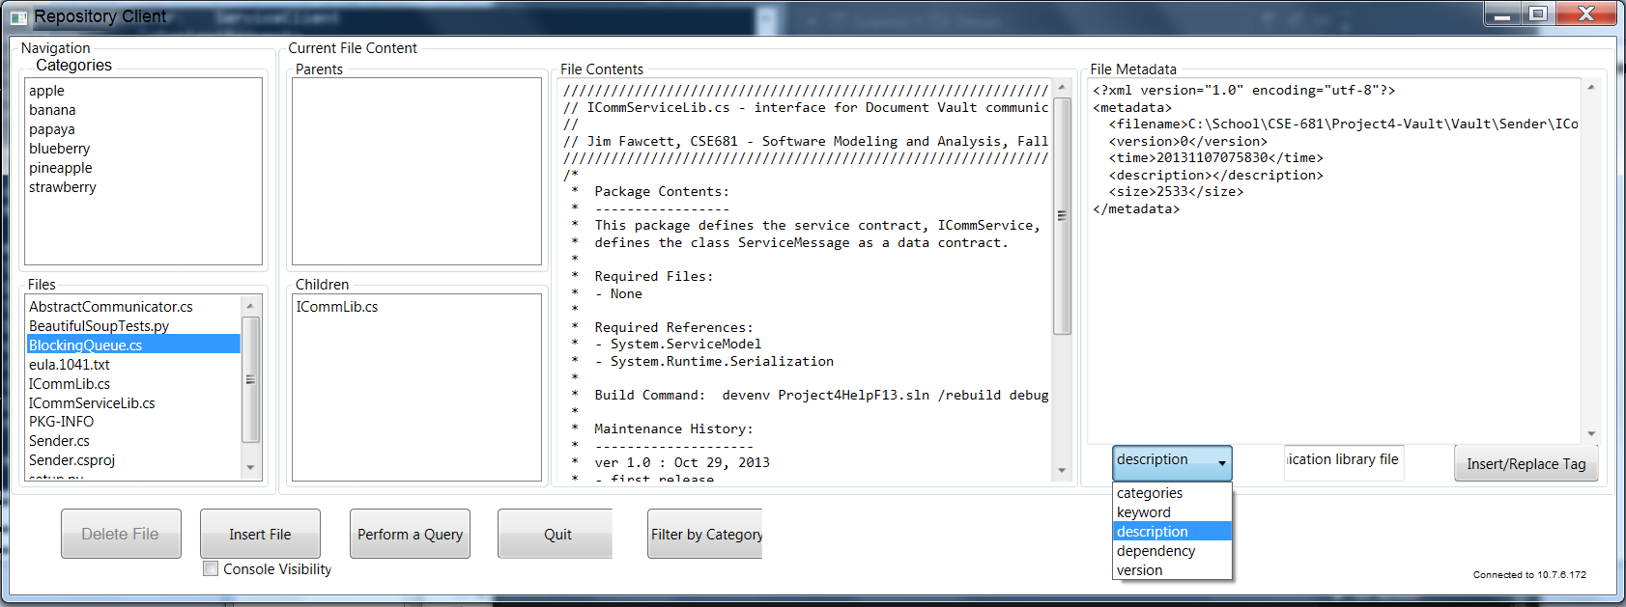
Figure 16: Nav View (NavGetClient)

Uses – NavGetServer
The NavGetServer handles incoming NavGet queries from the NavGetClient. The NavGetClient may exist within the Repository Client, or any other Server in the server federation.

Structure
The structure of the NavGet package is shown below in the UML package diagram in Figure 16. The top level packages, NavGetClient and NavGetServer compose the pair of NavGet plugin files.
Figure 17: NavGet UML Package Diagram
NavGetClient – The NavGetClient is one of the packages instantiated within the Nav View. This appears in a pane on the left side of the view.
NavGetServer – The NavGetServer shares messaging construction and parsing functions as implemented in the NavGet Service. The NavGetServer also shares credential information with the Authenticator package to check if the NavGetQuery is permitted for the user, and if each file reported within the NavGet ServiceMessage is permitted for view by the user. For more information, see §6.4.4.
Authenticator – The Authenticator package is used by the NavGetServer, in conjunction with user and password supplied by the user. The Authenticator package is also used by the NavGetClient when the Navigation View is used to log in during initial connection to the server.
MetadataRecursiveCrawl – See §6.8 for more information.
The MetadataRecursiveCrawl provides a .NET event-based facility for performing a function upon each metadata file within a dependency tree. NavGetServer uses this facility to check for the existence of all child source code packages for a given filename within the Repository Server.

Activities
NavGetQuery at the NavGetServer
- During the NavGetQuery, the logged-in user is recalled from the Authenticator package.
- The user is checked against the group list to see if the user is permitted to get Query results.
- If the user is permitted, the query is constructed by the NavGetServer.
- The file system is searched by the FileTable package, and each file with metadata of SourceCode type and with the user having permissible credentials is added to the NavQueryResponse.
- For each file, the applicable categories is added to the category list.
- For each file, the MetadataRecursiveCrawl package is used to tell if all of the dependencies for each file are present within the file system. The result of this dependency check is added to the NavQueryResponse.
  - For each missing dependency, add the missing filename and version to the missing dependency list for the current file.
NavGetQuery response at the NavGetClient
- The NavQuery response is unpacked by the NavQueryClient.
- The category list is updated using the category list content of the NavQuery response message, and the static member functions within the NavGet Service.
- The file list is updated using the file list content of the NavQuery response message, and the static member functions within the NavGet Service.
  - If a file dependency is missing, print this information next to the associated parent file.

Critical Issues
Authentication Security – The username and password can be swiped from the file system of the Client if the password is every written to a file. Encryption is helpful to temporarily impede progress of a dubious person. If the password is written to the file system, it is only a matter of time for someone to be able to get access. The password will therefore not be written to the file system, and the Server will have to keep track of client connections to ensure that the initial login that occurred at initial connection is still valid for a given IP address and port for a client connection. The communicator will have to support this type of secure connection, such as with use of SecurityMode set to ‘TransportWithMessageCredential’.

Repository Server: PackageGetServer/Client Packages

Concept
The PackageGetClient and Server package provide the second half of the information shown in the Nav View on the Repository Client. The difference between the NavGet package and this package is the NavGet package provides a high level listing of the content on the Repository Server; this package provides content and metadata for the currently selected file.
An entire source code package and all of its parents can be retrieved using the PackageGetClient if the user chooses to perform a full package PackageGet. The MetadataRecursiveCrawl package is used by the Repository Server to transfer each file in the dependency tree to the Repository Client.
Should the user choose to, the full package PackageGet can be used in conjunction with the cloning facility, available with all of the federated servers. Since the full set of plug in libraries that compose Repository Server are available with the Repository Client, the user needs only to point Repository Client to the running localhost (127.0.0.1) instance of Repository Server.

Uses

Users
The user, via the Repository Client will be the primary user of this package. Each time a file is updated or selected, the PackageGetClient issues a PackageGetQuery, which is handled by the Repository Server’s PackageGetServer. Additionally, the federated servers, such as the Test Server or Project Server may request file contents. A similar authentication is used in this package as with the NavGet package. All communications between client and server are secured, and content is only populated into a PackageGetQuery response if a file’s metadata contains the appropriate group level for the logged-in user.
The PackageGetClient package provides all of the content, functionality and messaging used to populate the “Current File Content” portion of the Repository Client. The populated “Current File Content” portion is shown below in the prototype diagram in Figure 17.
Figure 18: PackageGetClient portion of Repository Client - Prototype Diagram

Structure
The structure of the PackageGet package is shown below in the UML package diagram in Figure 17. The top level packages, PackageGetClient and PackageGetServer compose the pair of PackageGet plugin files.
Figure 19: PackageGet UML Package Diagram

PackageGetClient – Provides the remainder of the controls and indicators used within the Nav View, in conjunction with the NavGet package. When a PackageGetQuery response message arrives at the Repository Client, this package extracts metadata information from the PackageGetQuery, and opens a binary receiver for the content file if the metadata indicates a different version and file size/checksum. Caching is performed such that at the Client, a PackageGetQuery needs to result in a binary file transfer of the content file using BinFileComm one time.
PackageGetServer – This package receives the PackageGetQuery, and checks the authentication of the current user of RepositoryClient. If the PackageGetQuery is a full package PackageGetQuery, the PackageGetServer transfers all of the files in the dependency chain started with the file selected by the user. Otherwise, just the single selected file is transferred.
Given the caching strategy discussed above, if the server deteremines that the client already contains each individual file in the dependency tree, the transfer is skipped.
MetadataLib – This package is used by the PackageGetClient to write a LastAccessed time tag to the local metadata file. An entry is written to a file table, also using MetadataLib containing the cached filename. During the time of every startup of the Repository Client, the files that have LastAccessed time tags indicating ages greater than one week will be removed from the Repository Client’s file system, and the entry in the file table is pruned.
BinFileComm – This package is used upon request by the PackageGetClient, given that the file is not already present on the file system of the Repository Server. This package makes binary transfer of large files possible, given that WCF does not allow for exceedingly large files.

Critical Issues
Large files – WCF does support sending large files using chunking, but it must be set up to do so. This design proposes to use a separate binary file transfer package, BinFileComm. During potential development of PackageGetClient and Server, the possibility to configure WCF for chunking should be explored prior to development and testing of BinFileComm. It would be preferable to house all content transfer within WCF and the IComm package.

Repository Server: PackageCheckinServer/Client Packages

Concept
The PackageCheckin package provides the user the ability to introduce new versions and baselines of source code packages. The PackageCheckinClient provides the Insert View of the Repository Client. File content is cached using the same facility used within PackageGetQuery to reduce or eliminate unnecessary transfer of source code and other text files. The PackageCheckinServer uses a check in-only ownership policy, in which a file cannot be revisioned by anyone but the originally listed responsible individual. The Repository Server does not use check out, therefore any authenticated user that has proper user group membership can retrieve a source code package.

Uses

Users
The user will be the sole user of the PackageCheckinClient. The PackageCheckinServer will be responsible for handling check in attempts from the user. The test server will update test result contents within metadata using MetadataUpdate commands as documented in §6.7. Test result files will be inserted using the PackageCheckin, and a dependency will be added to the given source code package under test using the MetadataUpdate facility.
The Insert View will instantiate the MetadataUpdateClient WPF control on the right-hand side of the window. The MetadataUpdateClient is documented in §6.7.
An example view of the PackageCheckinClient is shown below in the prototype diagram in Figure 19.
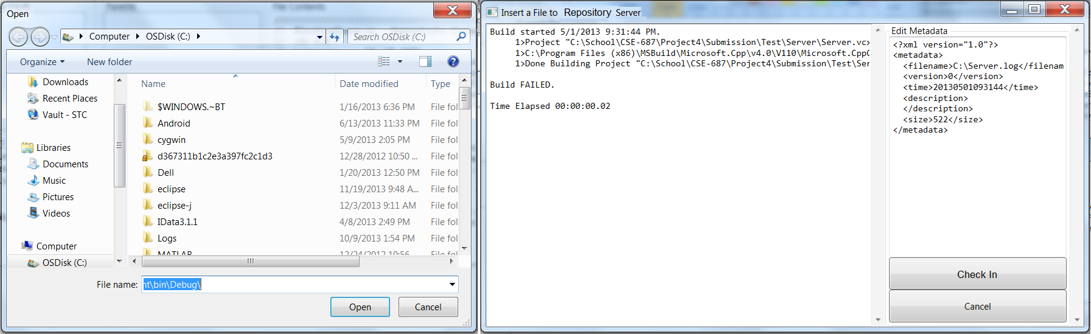
Figure 20: PackageCheckinClient Prototype Diagram

Structure
The PackageCheckinClient and PackageCheckinServer UML package diagram is shown below in Figure 20.
Figure 21: PackageCheckin UML Package Diagram
PackageCheckinClient – This package composes a customization of the AbstractCommunicator package, and includes a WPF implementation that contains the view shown in Figure 19.
PackageCheckinServer – This package receives a PackageCheckin Command, and checks the authentication of the current user of the Repository Client, and verifies that this user is the owner of a file if the checkin is a revision of an existing package.
PackageCheckinServer uses MetadataLib to write metadata files, and AbstractCommunicator’s BinFileComm (not shown) for writing source code packages to the Repository Server’s file system.

Activities
PackageCheckinClient
- User presses “insert file” on the Nav View.
- Show Open dialog.
  - If user selects cancel, return to Nav View.
- Otherwise, create a new metadata file content
  - Get the user’s description of the source code package
  - Get the source code package’s dependency list
  - Get the RI (current user)
- Create the PackageCheckin ServiceMessage (XML)
PackageCheckinServer
- Check the PackageCheckin ServiceMessage
  - Authenticated?
  - Already exists?
    - If so, is current user the RI?
- If check fails, send a PackageCheckin response indicating failure.
- Otherwise, start file transfer
- Check file, if ok, send a PackageCheckin response indicating pass. Check existence of all dependencies.
- Send a NavGet with an updated file list with missing dependencies.

Critical Issues
Ownership – Per the Repository Server ownership policy, files cannot be revisioned by anyone but the original RI. There is no check out; meaning any authenticated user that has access to a file (Authentication Group metadata tag) can perform a PackageGet. On one hand, the exclusive check-in ownership policy is simple from a design standpoint. On the other hand, if the package RI goes on vacation (temporary or permanent) this presents a problem. The proposed solution is to allow the administrator to also perform check -ins. It is recommended that a program manager for a given project authorize the administrator to do a check-in. The check in would then retain the owner RI for the checked in package’s metadata ReponsibleIndividual tag.

Repository Server: MetadataUpdateServer/Client Packages

Concept
The MetadataUpdateServer and Client package provide the ability to make changes to metadata for an already checked in package in the Repository Server. The implementation of MetadataUpdateClient will contain a WPF control that will be used in both the Insert View (CheckinClient) and the Nav View. Metadata changes will be rule-based, and will depend on a variety of parameters, such as the user’s authentication group, whether the package in question belongs to that user, and whether the metadata update is occurring from the Insert View or from the Nav View.
The MetadataUpdateServer will also support metadata updates from the Test and Project Server.

Uses
- The user will make changes to metadata from baseline submissions when checking in a new file.
- Additionally, the user will make changes to metadata on files that don’t belong to them.
- Finally, users will make changes to metadata on files that do belong to them.
- The user must be authenticated, and have access to the file’s metadata via the authentication group.
- Users that own a package have the ability to modify dependencies. This will rev bump the version listed in the metadata. This is used in conjunction to allow other packages to use old versions/revisions of source code.

Structure
The MetadataUpdateClient and MetadataUpdateServer UML package diagram is shown below in Figure 21.

Figure 22: MetadataUpdate UML Package Diagram
MetadataUpdateClient – This package is responsible for allowing the user to specify metadata changes from the Nav View and from the Insert View. The client will check the authentication, as well as the current logged in RI on a per-tag basis. Tags that are prohibited or inappropriate for editing will be greyed out in the MetadataUpdate WPF control. When the user chooses to send the updated of the metadata to the Repository Server, the MetadataUpdate packages up the metadata and sends the resulting XML to the MetadataUpdateServer.
MetadataUpdateServer – The Repository Server uses this package to receive incoming MetadataUpdate query messages. Based on the authentication of the current user, and whether the user is the responsible individual for the package, it will either use MetadataLib to write the new metadata to the Repository file system, or send a failing MetadataUpdate response back to the client for display to the user.

Critical Issues
Rule-based complexity – The above structure makes use of rule-based metadata editing, both at the Client and the Server. The Repository Client and Repository Server will make use of a rule file. This will be well-formed XML and will contain rules for all user groups, authentication statuses and ownership, versus the actions implemented by the plug ins. A given plug in, for example MetadataUpdate, will contain implementation of a given IAction interface. The name of the IAction will be listed in the rule file for each level of authentication, ownership and user group. This strategy presents a similar aim as the flexible “Parser” package, which uses IActions and IRules: rule-based complexity is solved with rule-based flexibility.
Keep old versions of source code packages for those that want to use them – The MetadataUpdate package uses the above policy management scheme to prevent anyone but the package RI from being able to modify the dependency content of a given package. If he/she wishes to make dependency changes, they are the only ones that can link to newer versions of source code.
Convenience - A notification system at the client will be used to keep the RI informed during the time when it is most convenient. If an RI is updating metadata via the Nav View, the Server will check if each parent’s version is the highest revision available. If it isn’t, the NavGet will include a notification to the user that “a newer version of XYZ package is available, would you like to update?”.

MetadataRecursiveCrawl

Concept
The MetadataRecursiveCrawl provides a .NET event-based facility for performing a function upon each metadata file within a dependency tree. NavGetServer uses this facility to check for the existence of all child source code packages for a given filename within the Repository Server.
The functionality and design philosophy is summarized in the following excerpt from the CSE-681 Fall 2013 Project 5 Specification:
…the metadata graph is virtual. It does not exist as an in-memory data structure. Instead all the graph
relationships are embedded into metadata files. To traverse the graph we open each metadata file in turn to get
navigation information, closing the file when we no longer need that information. Often that will be part of a
recursive search. The file is opened when we first navigate to that node of the graph, and is closed when the
recursion pops out of that node.

Uses
MetadataRecursiveCrawl package is used in analysis and modification of metadata (via MetadataLib) and iterates through dependency relationships from a given file (and its metadata) to all of the nodes in its dependency tree.
The NavGetServer package (documented in §6.4) uses the MetadataRecursiveCrawl package to return to the Repository Client a list of files and any potential missing packages from the Repository Server. This aids in ensuring, for an RI that all of the needed files for a Source Code package are present in the Repository Server.
The PackageGet package (documented in §6.5) uses the MetadataRecursiveCrawl package to return to the Repository Client a given Source Code package, as well as all of the files that it depends on, and all of the files its dependencies depend on, and so forth. This allows a top level source code package to be retrieved from the Repository Server for convenient development.

Structure
The MetadataRecursiveCrawl package structure is shown below in the UML class diagram in Figure 20. The MetadataRecursiveCrawl uses public event member which fires when a file is found in the dependency chain.
Figure 23: MetadataRecursiveCrawl UML Class Diagram
Because the root file is also a file in the dependency structure, the MetadataRecursiveCrawl activity requires a StartCrawl member function, which fires the metadataEvent event on the top file (passed via the rootFileName String parameter of the StartCrawl member function). The StartCrawl member function then calls the Crawl member function, which also fires the event and executes recursively on all dependencies.

Prototype
The following source code implements the MetadataRecursiveCrawl package.
///////////////////////////////////////////////////////////////////////////////
// MetadataRecursiveCrawl.cs - Recursive metadata search with public //
// delegate //
// //
// Matthew Synborski, CSE681 - Software Modeling and Analysis, Fall 2013 //
///////////////////////////////////////////////////////////////////////////////
/*
* Package Operations:
* -------------------
* This package contains three classes:
* someEventArgs
* Serves as a container class for the content files located by
* MetadataRecursiveCrawl.
* MetadataRecursiveCrawl
* Is a class for the MetadataRecursiveCrawl. This recursively searches metadata
* and fires an event on a file listed in the metadata dependency tags.
*
* Required Files:
* - MetadataRecursiveCrawl.cs Defines MetadataCrawl behavior
*
* Required References:
* - System.Linq
* - System.Threading.Tasks;
* - System.IO;
* - MetadataLib;
*
* Maintenance History:
* --------------------
* ver 1.0 : Nov 22, 2013
* - first release
*/
using System;
using System.Collections.Generic;
using System.IO;
using System.Linq;
using System.Text;
using System.Threading.Tasks;

namespace MetadataLib
{
public class metadataEventArgs : EventArgs
{
private string _msg;

public metadataEventArgs(string msg)
{
_msg = msg;
}

public string msg
{
get
{
return _msg;
}
set
{
_msg = value;
}
}

}

public class MetadataRecursiveCrawl
{
private List<String> dependencies = new List<String>();

public delegate void metadataEventHandler(object sender, EventArgs seva);
public event metadataEventHandler metadataEvent;

public override String ToString()
{
StringBuilder sb = new StringBuilder();
foreach (String s in dependencies)
{
sb.Append(s + ",");
}
return sb.ToString();
}

public void StartCrawl(String rootFileName)
{
if (File.Exists(rootFileName + ".metadata"))
{
dependencies.Add(rootFileName);
metadataEventArgs seva
= new metadataEventArgs(rootFileName);
if (metadataEvent != null)
metadataEvent(this, seva);
Crawl(rootFileName);
}
}

private void Crawl(String rootFileName)
{
if (File.Exists(rootFileName + ".metadata"))
{
var deps = MetadataLib.GetDependencies(rootFileName + ".metadata");
dependencies.AddRange(deps);
foreach (String s in deps)
{
metadataEventArgs seva
= new metadataEventArgs(s);
if (metadataEvent != null)
metadataEvent(this, seva);
Crawl(s);
}
}
}

static int Main()
{
var listCrawl = new MetadataRecursiveCrawl();
listCrawl.StartCrawl("AbstractCommunicator.cs");
Console.WriteLine(listCrawl.ToString());
return 0;
}
}
}

Example Demo of MetadataRecursiveCrawl
The following demo source code demonstrates a program that registers the public event within a MetadataRecursiveCrawl object with a member function that searches each metadata file in a source code dependency tree for the text term “namespace”.
The expected result of the demo is to find that the word “namespace” exists in:
- The root file, AbstractCommunicator.cs
- Its parent file, BlockingQueue.cs,
- Its parent files, ICommLib.cs and ICommLib2.cs
As shown below in the screenshot in Figure 21.
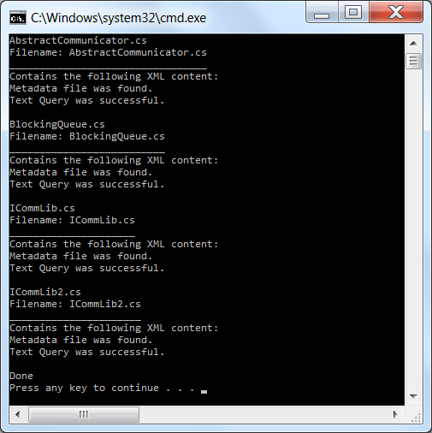
Figure 24: MetadataRecursiveCrawl Example Application Screenshot

The demo application’s source code, which briefly demonstrates the usage of the MetadataRecursiveCrawl package is shown below:
using System;
…
using System.Threading.Tasks;

using MetadataLib;
using TextAnalyzer;

namespace Demo
{
class Program
{
private List<XmlSearchResult_c> _xsr = new List<XmlSearchResult_c>();

public List<XmlSearchResult_c> GetSearchResults()
{ return _xsr; }
public Program(MetadataRecursiveCrawl metRecurse)
{
metRecurse.metadataEvent
+= new MetadataRecursiveCrawl.metadataEventHandler(TextSearch);
}
public void DisplayContents(object obj, EventArgs seva)
{
String filename = ((metadataEventArgs)seva).msg;

Console.WriteLine("{" + filename + "}");
Console.Write(File.ReadAllText(filename));
Console.WriteLine();
}
public void TextSearch(object obj, EventArgs seva)
{
String filename = ((metadataEventArgs)seva).msg;
List<String> ft = new List<String>();
ft.Add(filename);

_xsr.AddRange(TextQuery.run(ft, new String[] { "namespace" }, false, new String[]{} ));

}
static void Main(string[] args)
{
var listCrawl = new MetadataRecursiveCrawl();
var sub = new Program(listCrawl);
listCrawl.StartCrawl("AbstractCommunicator.cs");
foreach (XmlSearchResult_c xsr in sub._xsr)
{
Console.WriteLine(xsr.filename);
Console.WriteLine(xsr.ToString());
}
Console.WriteLine("Done");
}
}
}

Critical Issues
Flexibility – The most critical issue with MetadataRecursiveCrawl is flexibility. Users (the software developers that use it) need to be able to define and redefine actions and queries within metadata. The design uses events so that any software that includes an instance of this class can register any member function they choose to create.
Processing Load - .NET Events are quite convenient for developmental flexibility. Using events compared to other methods of invocation shouldn’t add much processing load. The source code repository will need to access potentially thousands or millions of source code files. According to an experiment using the following methods of invocation, using events, direct invocation, calls through an interface, and calls through Action<>, ten million calls of an event only added a cumulative total of 0.47 seconds. This overhead is therefore suitable for the Repository Server.
Source: http://stackoverflow.com/questions/3847727/performance-implications-of-net-events

